The requirement of the ML Engineer is to work in ML Ops team. Below is the lifecycle and team structure.

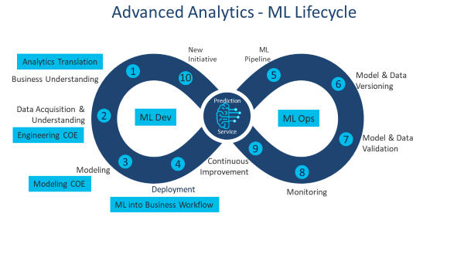

Task to be completed and presented during the interview.

1. Please create a single slide on your understanding of ML Ops (Machine Learning Operations)
2. Please use to the dataset available in https://www.kaggle.com/olistbr/marketing-funnel-olist
3. Please apply the ML Ops principle and develop a model to predict if the lead will get converted
4. Create the scripts for Data Extraction and converting it for model training and serving/prediction pipeline
5. Create the script to build model and save the model and version control
6. Create the script to use the saved model and do the prediction
7. Create scripts to validate the models
8. Create scripts to monitor the model performance
9. Continuous Integration and Deployment scripts using open source platforms of your choice
10. Summary of the approach and justification can be shared via public repository.